Azure VPN Gateway – Detailed Explanation
What is Azure VPN Gateway?
Azure VPN Gateway is a networking service that allows you to establish a secure, encrypted connection between your on-premises network and Azure Virtual Network (VNet) over the public internet using a VPN tunnel. It enables hybrid connectivity by allowing on-premises workloads to securely communicate with Azure resources.

How Azure VPN Gateway Works
Azure VPN Gateway consists of two key components:
- Virtual Network Gateway – A logical gateway that connects an Azure Virtual Network (VNet) to an on-premises network via VPN.
- Gateway Subnet – A dedicated subnet within the VNet that hosts the VPN Gateway.
When a VPN connection is established:
- Traffic is encrypted using protocols like IPsec/IKE.
- Data flows through a secure VPN tunnel over the public internet.
- On-premises devices or users can securely access Azure-hosted services and applications.

Types of VPN Connections in Azure
Azure VPN Gateway supports the following types of VPN connections:
1. Site-to-Site (S2S) VPN
- Used to connect an entire on-premises network to an Azure Virtual Network.
- Requires a VPN device (such as a firewall or router) in the on-premises network.
- Uses IPsec/IKE (IKEv2) for encryption.
- Typically used for hybrid cloud environments where Azure extends an on-premises data center.
✅ Use Case: Securely extending an on-premises data center into Azure.

2. Point-to-Site (P2S) VPN
- Used to allow individual clients (laptops, remote workers, or small offices) to connect to Azure securely.
- Works over the public internet without requiring a dedicated VPN device.
- Supports authentication methods like:
  - Azure Active Directory (Azure AD)
  - Certificate-based authentication
  - RADIUS authentication
- Uses IKEv2, OpenVPN, or SSTP protocols.
✅ Use Case: Securely connecting remote users to Azure resources without requiring a full site-to-site VPN.

3. VNet-to-VNet VPN
- Connects two or more Azure Virtual Networks (VNets) securely over a VPN tunnel.
- Useful for connecting VNets across different Azure regions.
- Uses the same IPsec/IKE (IKEv2) protocols as Site-to-Site VPN.
✅ Use Case: Securely connecting multiple Azure VNets in different locations.

4. Multi-Site VPN
- Similar to Site-to-Site VPN, but connects multiple on-premises networks to a single Azure Virtual Network.
- Uses multiple VPN tunnels to support multiple on-premises sites.
- Can be combined with ExpressRoute for backup connectivity.
✅ Use Case: When an organization has multiple branch offices that need secure connections to Azure.

5. ExpressRoute with VPN Failover
- ExpressRoute provides a dedicated private connection to Azure.
- VPN Gateway can be used as a backup in case ExpressRoute fails.
- Ensures high availability for hybrid cloud deployments.
✅ Use Case: Ensuring redundancy for a private ExpressRoute connection.

VPN Gateway Architecture
1. Components of a VPN Gateway
Component | Description
Virtual Network (VNet) | Azure's private network where your resources reside.
Gateway Subnet | A dedicated subnet for the VPN Gateway (minimum /27 size).
Virtual Network Gateway | The logical gateway that facilitates VPN connectivity.
Local Network Gateway | Represents your on-premises network (contains the public IP address of the VPN device).
Connection | The actual VPN tunnel between Azure VPN Gateway and the on-premises VPN device.

Supported VPN Protocols
Azure VPN Gateway supports the following VPN protocols:
Protocol | Description
IPsec/IKEv2 | Most common, used for Site-to-Site (S2S) and VNet-to-VNet VPNs.
IKEv2 | Used for Point-to-Site (P2S) VPNs on Windows, macOS, and iOS.
OpenVPN | Used for P2S VPNs, widely supported across platforms.
SSTP (Secure Socket Tunneling Protocol) | Supported only for P2S VPNs on Windows clients.

VPN Gateway Pricing & Performance
Azure VPN Gateway SKUs determine the performance, throughput, and number of connections a gateway can handle.
VPN Gateway SKU | Max Throughput | Max S2S Tunnels | Max P2S Connections
Basic | 100 Mbps | 10 | 128
VpnGw1 | 650 Mbps | 10 | 250
VpnGw2 | 1 Gbps | 10 | 500
VpnGw3 | 1.25 Gbps | 10 | 1000
VpnGw4 | 5 Gbps | 30 | 5000
VpnGw5 | 10 Gbps | 30 | 10000
🔹 Note: Performance may vary based on encryption settings, traffic load, and latency.

High Availability for Azure VPN Gateway
1. Active-Active VPN
- Deploys two VPN Gateway instances for redundancy.
- Ensures automatic failover between two tunnels.
- Supported only with Route-Based VPN.
2. Active-Passive VPN
- Deploys a single VPN Gateway instance.
- If the active instance fails, Azure automatically provisions a new one.

Steps to Set Up a Site-to-Site VPN in Azure
1. Create a Virtual Network (VNet)
- Define an IP address range for the VNet (e.g., 10.0.0.0/16).
- Create a subnet for application workloads (e.g., 10.0.1.0/24).
2. Create a Gateway Subnet
- Create a subnet named "GatewaySubnet" (e.g., 10.0.255.0/27).
3. Deploy a Virtual Network Gateway
- Choose VPN as the gateway type.
- Select Route-Based VPN (recommended).
- 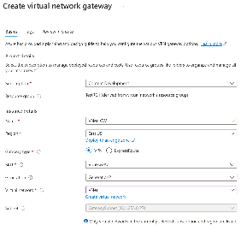
- 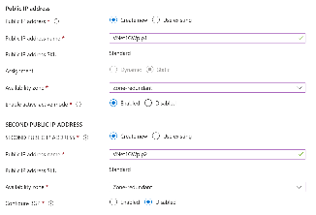
4. Configure Local Network Gateway
- Enter the public IP address of the on-premises VPN device.
- Define the on-premises subnet ranges.
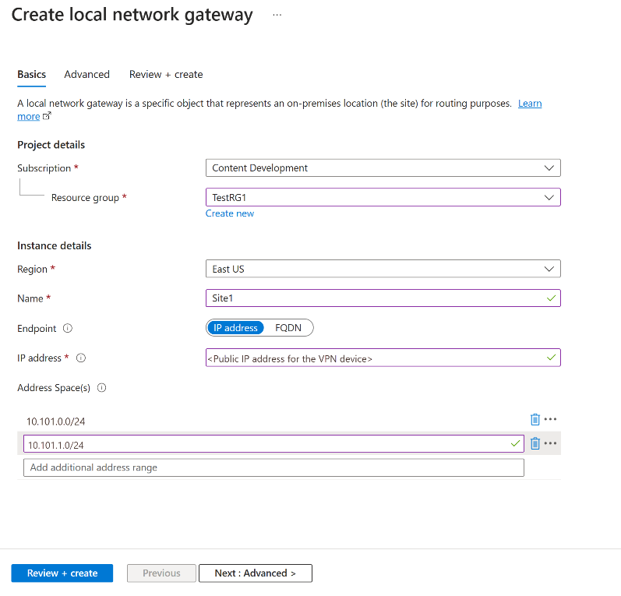
5. Create a VPN Connection
- Link the Virtual Network Gateway and Local Network Gateway.
- Choose IPsec/IKE as the encryption protocol.
6. Configure the On-Premises VPN Device
- Set up a VPN tunnel on your firewall/router.
- Apply the IPsec/IKE settings.
7. Verify the VPN Connection
- Check connection status in Azure Portal.
- Use PowerShell:
pgsql
CopyEdit
Get-AzVirtualNetworkGatewayConnection -Name "MyVPNConnection" -ResourceGroupName "MyResourceGroup"

Advantages of Using Azure VPN Gateway
✅ Secure & Encrypted: Uses industry-standard IPsec/IKE protocols.
✅ Hybrid Connectivity: Extends on-premises networks to Azure securely.
✅ Multiple VPN Types: Supports S2S, P2S, VNet-to-VNet, and Multi-Site VPNs.
✅ High Availability: Active-Active and Active-Passive options.
✅ Scalable Performance: Different VPN Gateway SKUs for different workloads.

Conclusion
Azure VPN Gateway is a critical service for secure hybrid cloud networking, enabling encrypted communication between on-premises networks and Azure Virtual Networks (VNets). It supports multiple VPN types, ensuring scalability, reliability, and high availability for businesses moving to the cloud.

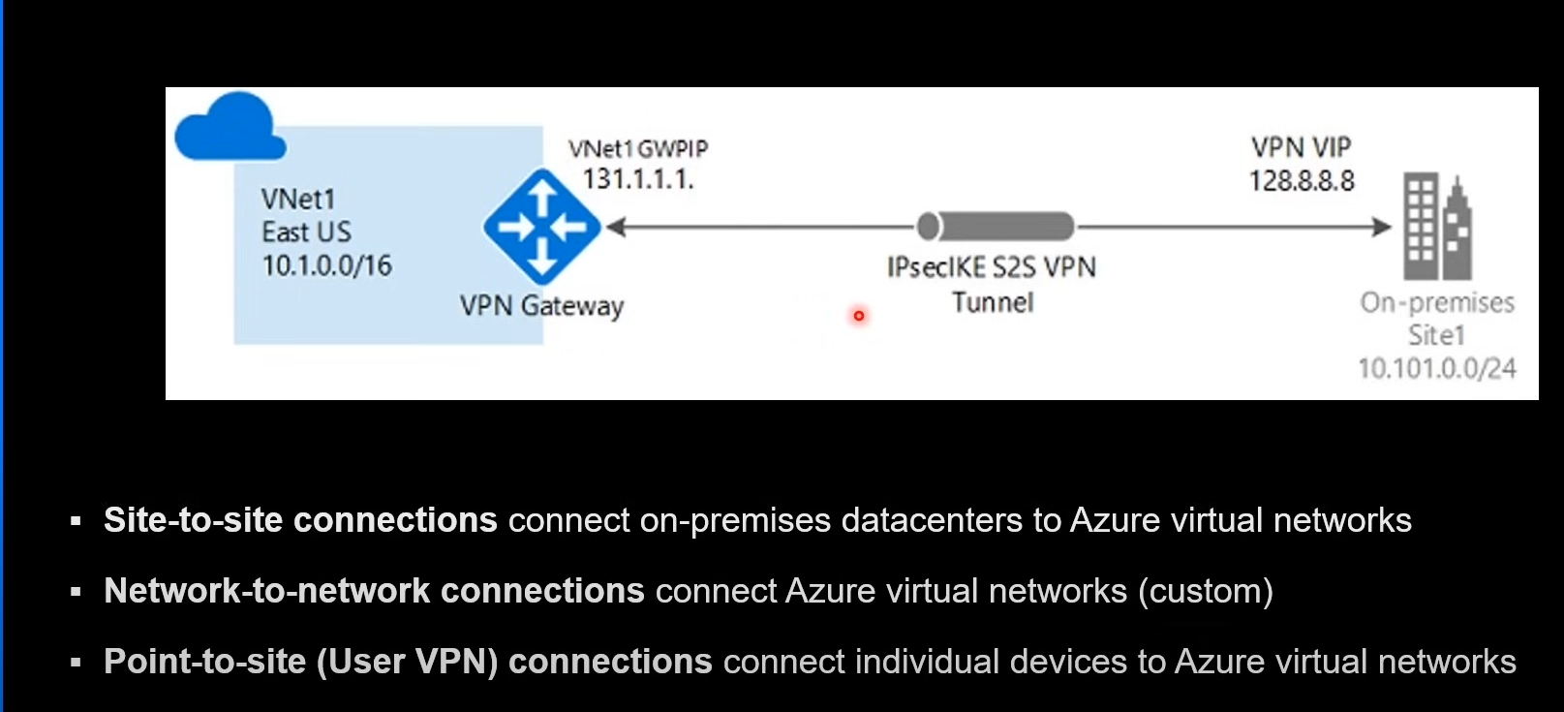
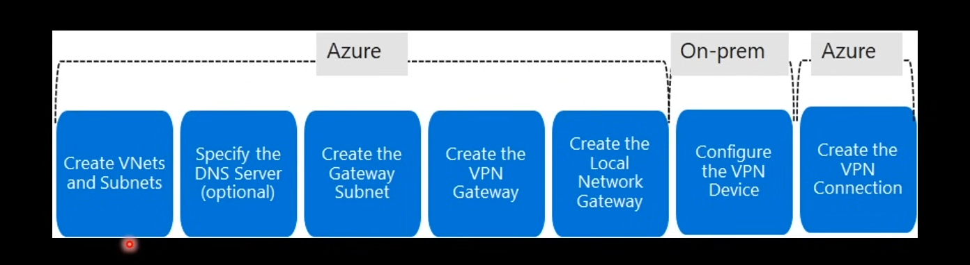

Express route
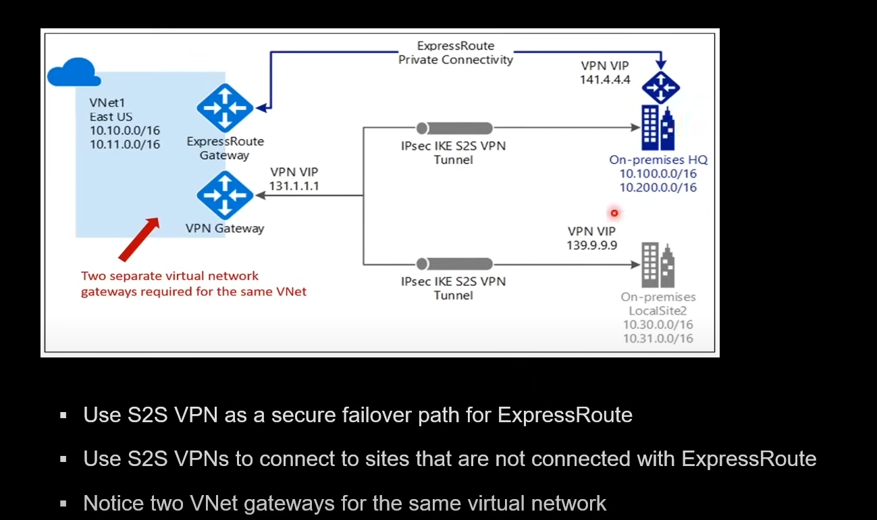
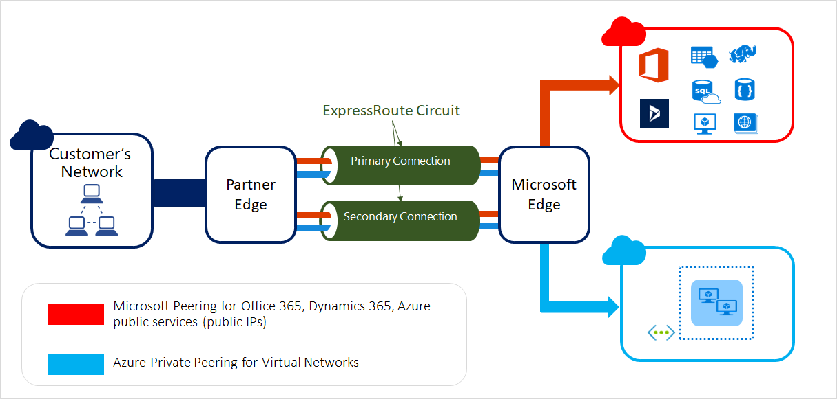

ExpressRoute lets you extend your on-premises networks into the Microsoft cloud over a private connection with the help of a connectivity provider. With ExpressRoute, you can establish connections to Microsoft cloud services, such as Microsoft Azure and Microsoft 365.
Note
If you have expressroute circuit in the infra then only we can use that in the Virtual network gate way. Express route

PrivateLink/DNS-Integration-P2S/readme.md at master · dmauser/PrivateLink

Point to Site VPN name resolution behavior
By design Azure VPN client will set and use DNS servers that are either set on Virtual Network DNS Server or specified in client XLM profile. In case your Virtual Network is set to use Azure Provided DNS (168.63.129.16) you will not be able to resolve Private Endpoint. In case you don’t want to define DNS at the VNET level, you can still set DNS Server configuration directly on client XLM profile, and set the IP to a DNS Forwarder/Proxy running on Azure. As stated on previous session a DNS Forwarder/Proxy is required to P2S VPN clients be able to resolve endpoints. Another very important consideration, when you validating this solution, is to know that nslookup is not the right tool to make the private endpoint name resolution (DNS) validation over P2S VPN connections. Windows 10 has a feature called Network Resolution Policy Table (NRPT) and VPN connections will add DNS information inside NRPT.
Because Nslookup is not aware of NPTR and you must use PowerShell Resolve-DNSName cmdlet to check DNS name resolution over P2S VPN connections (see examples below of how to do proper DNS name resolution validations).

